Apartment Management System
SRS Document

Instructor:
Eng. Rasheed Aldhaferi

Made By:
Mohammed Alsamawi
Aiham Alhalmi
Habib Sabri

Chapter 1: Introduction

1.1 Purpose
This Software Requirements Specification (SRS) defines the functional, nonfunctional, business, interface, data, and use-case requirements for AMS V1.0. It provides a shared agreement among the project sponsor, project team, building managers, building owners, and other stakeholders about what the system shall do and the boundaries within which it shall operate.

1.2 Document Conventions
The word “shall” identifies a mandatory requirement; “should” identifies a recommended requirement; and “may” identifies an optional capability. Requirement IDs use a two-letter category prefix and a three-digit sequence number.
Artifact | ID Pattern | Example
Functional requirement | FR-### | FR-001
Nonfunctional requirement | NFR-### | NFR-001
Business rule | BR-### | BR-001
Interface requirement | IR-### | IR-001
Data requirement | DR-### | DR-001
Use case | UC-### | UC-001
Issue / open question | ISS-### | ISS-001

1.3 Intended Audience and Reading Suggestions
Building managers should begin with the project scope, product features, functional requirements, use cases, and user stories. Building owners and the sponsor should review scope, business rules, nonfunctional requirements, reports, and issues. Developers should use the full document, especially interfaces, data requirements, constraints, and traceability. Testers should focus on testable requirement statements and acceptance criteria.

1.4 Project Scope
AMS covers local apartment and occupancy records, rent and payment tracking, maintenance issue logging, parcel receiving, local SQLite persistence, authentication, role control, backup/restore, PDF report export (CR-002), and Arabic/English UI toggle (CR-003). The system shall support Windows 10/11 desktop operation and 100% offline capability. Online payments, cloud sync, mobile apps, SMS/email gateways, and multi-building SaaS are explicitly excluded.

1.5 References
IEEE-style SRS structure and terminology used in the Software Engineering Tutorial lab manuals.
AMS project idea and approved change requests CR-002 and CR-003 supplied by the project team.
SQLite database technology and ACID transaction principles selected as project implementation constraints.

1.6 Overview
Chapter 2 describes the overall product, users, operating environment, constraints, documentation, assumptions, and dependencies. Chapters 3-6 define system behavior and quality attributes. Appendix A provides user stories and acceptance criteria; Appendix B provides UML analysis and design models; Appendix C lists open issues and questions.

Project Idea Summary
Apartment Management System (AMS) is a desktop-based, local-first property management software product, Version 1.0.

Problem Statement
Local apartment building managers and owners often rely on paper ledgers, fragmented logs, and memory to track rent, vacancies, parcel deliveries, and repair requests. This creates duplicated records, delayed follow-up, unclear balances, and limited visibility into building operations. AMS will digitize and centralize these operations in a single Windows desktop application that remains usable without internet access.

Target Users
User | Role in AMS | Primary Needs
Building Managers | Primary operational users | Maintain apartments and tenants, record rent, log issues, receive parcels, and view summaries.
Building Owners | Business owners and administrators | Review financial and operational status, manage users, and control backup/restore.
Apartment Tenants | Secondary beneficiaries | Receive accurate rent records, parcel pickup confirmation, and issue follow-up.
Operations Lead / Staff | Supporting operational users | Process assigned maintenance and parcel tasks within granted permissions.

Main Features
Module | Main Features
Apartment & Occupancy Management | Create units, map rooms, assign tenants, track vacancies and occupancy status.
Rent & Payment Tracking | Compute local rent, record cash/docket payments, classify payment status, calculate overdue balances.
Maintenance & Issue Logging | Create repair requests, classify priority, assign responsibility, and move issues Open → In Progress → Resolved.
Package & Parcel Receiving | Check in parcels, record courier/tracking data, confirm tenant pickup, and search parcel history.
Local Database & Persistence Layer | SQLite storage, ACID transactions, local authentication, role permissions, backup and restore.
Approved Changes | CR-002 PDF report export and CR-003 Arabic/English UI toggle.

Scope Boundary
AMS is strictly offline-capable and intended for one local apartment-building operation in V1.0. Online payments, cloud synchronization, mobile applications, SMS/email gateways, and multi-building SaaS are out of scope.

Chapter 2: Overall Description

2.1 Product Perspective
AMS is a standalone Windows desktop application for a local apartment-building operation. It replaces disconnected paper ledgers and informal logs with a unified user interface and local SQLite persistence layer. The product is local-first: core operations do not require internet, external services, or cloud accounts.

2.2 Product Features
Feature Area | Description | Priority
Occupancy | Apartment/unit setup, room mapping, tenant assignment, and status dashboard. | Must Have
Rent | Rent calculation, cash/docket payment records, payment status, overdue balance, reports. | Must Have
Maintenance | Issue creation, priority, assignment, status workflow, resolution notes. | Must Have
Parcels | Package check-in, tracking details, storage location, pickup confirmation. | Must Have
Persistence and Security | SQLite, ACID transactions, authentication, roles, backup/restore. | Must Have
Approved Enhancements | PDF report export and Arabic/English UI toggle. | Should Have

2.3 User Classes and Characteristics
User Class | Characteristics and Responsibilities
Building Manager | Frequent operational user; maintains records and processes daily transactions.
Building Owner | Administrative and oversight user; reviews reports, manages access, and controls backups.
Operations Staff | Limited operational user; handles assigned maintenance or parcel tasks.
Apartment Tenant | Secondary beneficiary; receives accurate records and service follow-up, but is not a primary V1.0 operator.

2.4 Operating Environment
Windows 10 or Windows 11 desktop, supported 64-bit environment. Local SQLite database stored on the same managed computer or approved local storage. Keyboard and mouse input with a standard desktop display. Optional local printer or PDF-capable print workflow for reports. No internet connection, web server, mobile device, SMS gateway, or cloud service is required.

2.5 Design and Implementation Constraints
The product must be 100% offline-capable for core operations. SQLite is the required local persistence technology and transactions must preserve ACID behavior. Access is controlled through local authentication and role permissions. V1.0 supports one local building operation; multi-building SaaS is excluded. Approved changes are limited to CR-002 PDF export and CR-003 Arabic/English UI toggle.

2.6 User Documentation
The delivery shall include a concise manager guide, owner administration guide, backup/restore instructions, field definitions, and in-application validation/help text. Documentation shall explain common workflows without assuming technical knowledge.

2.7 Assumptions and Dependencies
Item | Assumption / Dependency | Impact
Users | Managers and owners have basic Windows and data-entry skills. | Training remains short and task-focused.
Building data | Apartment numbers, room maps, rent rules, and tenant details are supplied by the owner. | Initial setup depends on accurate source records.
Hardware | The target computer has sufficient storage and a supported Windows version. | Performance and backup depend on local hardware.
Policy | Cash/docket payment and parcel confirmation policies are defined by the building owner. | Business rules must be confirmed before release.
Localization | Arabic and English labels are prepared for CR-003. | Translation completeness affects usability.

Chapter 3: Functional Requirements
The following requirements describe observable AMS behavior. Each statement is uniquely identified, testable, and assigned a priority and source. “Must Have” requirements define the V1.0 baseline; “Should Have” requirements are approved or high-value additions.
ID | Requirement Statement | Priority | Source
FR-001 | The system shall allow an authorized manager to create an apartment record with a unique apartment number. | Must Have | Building Manager
FR-002 | The system shall allow the manager to define rooms, room labels, and occupancy capacity for each apartment. | Must Have | Building Manager
FR-003 | The system shall display apartment status as Vacant, Partially Occupied, Occupied, Reserved, or Inactive. | Must Have | Building Manager
FR-004 | The system shall assign one or more active tenants to an apartment and record move-in and move-out dates. | Must Have | Building Manager
FR-005 | The system shall prevent assignment of a tenant to an inactive apartment. | Must Have | Business Rule
FR-006 | The system shall search and filter apartments by number, status, tenant, and room. | Should Have | Building Manager
FR-007 | The system shall calculate the current rent amount from the apartment rent configuration and applicable period. | Must Have | Building Manager
FR-008 | The system shall record cash or docket rent payments with payer, amount, date, period, and receipt reference. | Must Have | Building Manager
FR-009 | The system shall classify a payment as Full, Partial, Pending, or Overdue according to the recorded amount and due date. | Must Have | Business Rule
FR-010 | The system shall calculate and display the outstanding balance for each tenant and apartment. | Must Have | Building Manager
FR-011 | The system shall allow authorized users to correct a payment record while preserving an audit note. | Should Have | Building Owner
FR-012 | The system shall generate printable or PDF-exportable rent and balance reports. | Should Have | CR-002
FR-013 | The system shall allow a manager to create a maintenance issue with apartment, description, category, priority, and reporter. | Must Have | Building Manager
FR-014 | The system shall support issue statuses Open, In Progress, and Resolved. | Must Have | Building Manager
FR-015 | The system shall allow authorized users to assign an issue to a responsible staff member and record resolution notes. | Should Have | Building Manager
FR-016 | The system shall filter maintenance issues by status, priority, apartment, and date range. | Should Have | Building Manager
FR-017 | The system shall record package check-in details including tenant, courier, tracking number, received date, and storage location. | Must Have | Building Manager
FR-018 | The system shall mark a parcel as Picked Up only after recording pickup date and receiver confirmation. | Must Have | Building Rule
FR-019 | The system shall search parcels by tracking number, tenant, status, and date. | Should Have | Building Manager
FR-020 | The system shall create, read, update, and archive records in a local SQLite database. | Must Have | Technical Constraint
FR-021 | The system shall authenticate users locally using a username, password, and assigned role. | Must Have | Building Owner
FR-022 | The system shall enforce role permissions for manager, owner, and staff operations. | Must Have | Building Owner
FR-023 | The system shall allow an authorized owner to perform a database backup and restore. | Must Have | Building Owner
FR-024 | The system shall provide an Arabic/English interface toggle without changing stored business data. | Should Have | CR-003
FR-025 | The system shall show a dashboard summarizing occupancy, outstanding rent, open issues, and uncollected parcels. | Should Have | Building Manager

Chapter 4: External Interface Requirements
Interface requirements define how users, software components, hardware devices, and communication channels interact with AMS. They intentionally reinforce the offline boundary of V1.0.
ID | Statement | Type | Priority
IR-001 | The application shall provide a login screen with username, password, authentication result, and recovery guidance. | User Interface | Must Have
IR-002 | The application shall provide a dashboard with navigation to occupancy, rent, issues, parcels, reports, users, and backup/restore according to role. | User Interface | Must Have
IR-003 | Data-entry forms shall display field labels, required-field markers, validation messages, and Save/Cancel actions. | User Interface | Must Have
IR-004 | The interface shall provide an Arabic/English toggle for supported labels and messages. | User Interface | Should Have
IR-005 | The application shall support keyboard navigation and readable tabular lists. | User Interface | Should Have
IR-006 | The software interface shall use SQLite for local persistence through a controlled data-access layer. | Software Interface | Must Have
IR-007 | The reporting interface shall export selected reports to PDF using the local print/export workflow. | Software Interface | Should Have
IR-008 | The application shall use the Windows file system for approved local database backup and restore files. | Software Interface | Must Have
IR-009 | The application shall support standard keyboard, mouse, monitor, and local printer/PDF output devices. | Hardware Interface | Should Have
IR-010 | Core AMS operations shall not require a network or internet communication interface. | Communication Interface | Must Have
IR-011 | If a future local network integration is considered, it shall be treated as a separately approved change and shall not be assumed by V1.0. | Communication Interface | Must Have

Chapter 5: Other Nonfunctional Requirements
Nonfunctional requirements define the quality attributes and operational constraints that apply to AMS behavior. They are written so that verification can be planned through inspection, demonstration, or testing.
ID | Statement | Category | Priority | Source
NFR-001 | The system shall open the dashboard within 5 seconds on a supported Windows desktop with a database of up to 10,000 active records. | Performance | Must Have | Building Owner
NFR-002 | The system shall save a normal record transaction within 2 seconds after the user confirms it. | Performance | Must Have | Building Manager
NFR-003 | The system shall require authenticated login before protected data or operations are accessible. | Security | Must Have | Building Owner
NFR-004 | The system shall store passwords using a one-way salted hash and shall not display them in plain text. | Security | Must Have | Technical Constraint
NFR-005 | The system shall restrict create, edit, delete, backup, and restore actions according to role permissions. | Security | Must Have | Building Owner
NFR-006 | A trained building manager shall be able to record a common transaction without consulting technical support. | Usability | Must Have | Building Manager
NFR-007 | The interface shall use consistent labels, validation messages, keyboard navigation, and visible save/cancel actions. | Usability | Should Have | Building Manager
NFR-008 | The system shall operate fully offline after installation and shall not depend on internet connectivity for core functions. | Compatibility | Must Have | Project Scope
NFR-009 | The application shall run on supported 64-bit Windows 10 and Windows 11 desktop environments. | Compatibility | Must Have | Project Scope
NFR-010 | The system shall preserve committed records after an application restart or power interruption affecting a completed transaction. | Reliability | Must Have | Building Owner
NFR-011 | The database shall maintain ACID-compliant transactions for related updates. | Reliability | Must Have | Technical Constraint
NFR-012 | Backup and restore shall provide a clear success or failure message and shall not silently overwrite the active database. | Reliability | Must Have | Building Owner
NFR-013 | The code shall separate user interface, application logic, and persistence responsibilities. | Maintainability | Should Have | Technical Team
NFR-014 | The system shall log significant authentication, backup, restore, and payment-correction events. | Maintainability | Should Have | Building Owner

Chapter 6: Other Requirements

6.1 Business Rules
Business rules express policies, restrictions, and conditions imposed by the building operation. They control how AMS validates data and transitions between business states.
ID | Rule Statement | Category | Related Requirements
BR-001 | Each apartment number shall be unique within the local building database. | Data Integrity | FR-001, FR-020
BR-002 | An inactive apartment shall not receive a new tenant assignment. | Occupancy Policy | FR-003, FR-005
BR-003 | A tenant may be assigned only one active apartment assignment at a time. | Occupancy Policy | FR-004
BR-004 | A payment amount shall be greater than zero and shall not exceed the configured amount unless an authorized correction note exists. | Payment Policy | FR-008, FR-011
BR-005 | Full payment means the recorded amount is equal to or greater than the applicable rent for the period. | Payment Policy | FR-009, FR-010
BR-006 | A payment period remains Pending until a valid payment record is confirmed. | Payment Policy | FR-009
BR-007 | Overdue status applies when a due date has passed and the outstanding balance is greater than zero. | Payment Policy | FR-009, FR-010
BR-008 | Maintenance priority shall be Low, Medium, High, or Critical; Critical issues require immediate owner/manager attention. | Maintenance Policy | FR-013, FR-014
BR-009 | Issue status shall follow Open → In Progress → Resolved; reopening requires an explanation. | Maintenance Workflow | FR-014, FR-015
BR-010 | A parcel shall not be marked Picked Up without pickup date and receiver confirmation. | Parcel Policy | FR-017, FR-018
BR-011 | Tracking number shall be recorded when supplied by the courier and shall be unique among active parcel records. | Parcel Policy | FR-017, FR-019
BR-012 | Only authorized owner-level users may restore a database backup. | Security Policy | FR-022, FR-023
BR-013 | Deleting operational records shall be replaced by archival where historical traceability is required. | Audit Policy | FR-020, NFR-014
BR-014 | AMS V1.0 shall not initiate online payment, cloud synchronization, SMS, or email communication. | Scope Control | FR-020, NFR-008

6.2 Data Requirements
AMS shall store the following entities in SQLite. Primary keys are local identifiers; foreign keys preserve relationships. Dates use a consistent ISO-compatible representation, monetary values use a fixed decimal representation, and required fields shall be validated before commit.

6.2.1 Tenants
Field | Type | Constraints / Validation
TenantID | INTEGER | PK, required, unique
FullName | TEXT | required, 2–120 chars
Phone | TEXT | optional, validated format
NationalID | TEXT | optional, unique if supplied
ApartmentID | INTEGER | FK, required for active assignment
MoveInDate | DATE | required for active assignment
MoveOutDate | DATE | nullable, >= MoveInDate
Status | TEXT | Active or Inactive

6.2.2 Apartments
Field | Type | Constraints / Validation
ApartmentID | INTEGER | PK, required, unique
ApartmentNumber | TEXT | required, unique
Floor | INTEGER | required, non-negative
RoomCount | INTEGER | required, > 0
MonthlyRent | DECIMAL | required, >= 0
OccupancyStatus | TEXT | controlled value set
IsActive | BOOLEAN | required

6.2.3 PaymentRecords
Field | Type | Constraints / Validation
PaymentID | INTEGER | PK, required, unique
TenantID | INTEGER | FK, required
ApartmentID | INTEGER | FK, required
Amount | DECIMAL | required, > 0
PaymentDate | DATE | required
RentPeriod | TEXT | required, normalized period
Method | TEXT | Cash or Docket
Status | TEXT | Full, Partial, Pending, Overdue
ReceiptReference | TEXT | optional, unique if supplied
CorrectionNote | TEXT | required for correction

6.2.4 Issues
Field | Type | Constraints / Validation
IssueID | INTEGER | PK, required, unique
ApartmentID | INTEGER | FK, required
ReportedBy | INTEGER | FK UserID, required
Description | TEXT | required, 5–1000 chars
Category | TEXT | controlled value
Priority | TEXT | Low/Medium/High/Critical
Status | TEXT | Open/In Progress/Resolved
AssignedTo | INTEGER | FK UserID, nullable
CreatedAt | DATETIME | required
ResolvedAt | DATETIME | nullable
ResolutionNotes | TEXT | required when Resolved

6.2.5 Parcels
Field | Type | Constraints / Validation
ParcelID | INTEGER | PK, required, unique
TenantID | INTEGER | FK, required
Courier | TEXT | required, 2–100 chars
TrackingNumber | TEXT | optional, unique among active
ReceivedDate | DATE | required
StorageLocation | TEXT | required
Status | TEXT | Received/Picked Up/Returned
PickupDate | DATE | nullable, required when Picked Up
ReceiverConfirmation | TEXT | nullable, required when Picked Up

6.2.6 Users
Field | Type | Constraints / Validation
UserID | INTEGER | PK, required, unique
Username | TEXT | required, unique
PasswordHash | TEXT | required, never plain text
FullName | TEXT | required
RoleID | INTEGER | FK, required
IsActive | BOOLEAN | required
LastLogin | DATETIME | nullable

6.2.7 Roles
Field | Type | Constraints / Validation
RoleID | INTEGER | PK, required, unique
RoleName | TEXT | required, unique
Permissions | TEXT | required, controlled permission set
Description | TEXT | optional

6.2.8 Storage and Integrity Requirements
ID | Requirement | Category | Priority | Related
DR-001 | The system shall persist all approved entities in a local SQLite database. | Storage | Must Have | FR-020
DR-002 | Primary and foreign keys shall enforce entity identity and valid relationships. | Integrity | Must Have | FR-020
DR-003 | Required fields and controlled values shall be validated before database commit. | Validation | Must Have | FR-001–FR-023
DR-004 | Related changes shall commit atomically or roll back as one transaction. | Integrity | Must Have | NFR-011
DR-005 | Backups shall be restorable and shall retain the database schema and operational records. | Backup | Must Have | FR-023
DR-006 | Archived records shall remain distinguishable from active records and shall not appear in default operational views. | Retention | Should Have | BR-013

Appendix A: User Stories and Acceptance Criteria

A.1 User Stories
Each story follows the course format “As a [role], I want [feature], so that [benefit].” Stories are linked to the AMS module and prioritized for planning and acceptance testing.
Story ID | User Story | Module | Priority
US-001 | As a building manager, I want to create apartments and map their rooms, so that the building inventory is accurate. | Apartment & Occupancy | Must Have
US-002 | As a building manager, I want to assign tenants and see occupancy status, so that I can identify vacancies quickly. | Apartment & Occupancy | Must Have
US-003 | As a building manager, I want to record a cash or docket rent payment, so that each tenant balance is current. | Rent & Payments | Must Have
US-004 | As a building owner, I want rent and overdue reports exported to PDF, so that I can review and share a reliable record. | Rent & Payments | Should Have
US-005 | As a tenant or manager, I want a repair issue to have a priority, so that urgent problems receive attention first. | Maintenance | Must Have
US-006 | As a manager, I want to move an issue from Open to In Progress to Resolved, so that repair progress is traceable. | Maintenance | Must Have
US-007 | As a building manager, I want to check in a parcel with courier and tracking details, so that deliveries are not lost. | Parcels | Must Have
US-008 | As a building manager, I want pickup confirmation recorded, so that parcel handover is accountable. | Parcels | Must Have
US-009 | As a building owner, I want local authentication and role permissions, so that sensitive operations are protected. | Persistence & Security | Must Have
US-010 | As a building owner, I want to back up and restore the local database, so that operational records can be recovered. | Persistence & Security | Must Have
US-011 | As a manager, I want an Arabic/English UI toggle, so that staff can use the interface comfortably. | Persistence & Security | Should Have
US-012 | As a building manager, I want one dashboard for occupancy, rent, issues, and parcels, so that daily decisions are faster. | Cross-module Dashboard | Should Have

A.2 Acceptance Criteria
The criteria below use Given/When/Then statements so that selected AMS user stories can be verified through repeatable demonstrations or tests.
Story | AC ID | Given | When | Then
US-001 | AC-001 | a manager is authenticated and the apartment number is unused | the manager saves a new apartment with valid room and rent data | the apartment is stored with Active status and appears in the apartment list
US-002 | AC-002 | an active apartment has capacity and the tenant data is valid | the manager confirms the tenant assignment | the tenant is linked to the apartment and occupancy status is recalculated
US-003 | AC-003 | a tenant and rent period exist and the payment amount is positive | the manager records a cash payment equal to the rent | the payment is saved as Full and the outstanding balance becomes zero
US-003 | AC-004 | a tenant has a nonzero rent balance | the manager records a valid amount less than the rent | the payment is saved as Partial and the remaining balance is displayed
US-005 | AC-005 | an apartment exists and the issue description is valid | the manager creates a Critical issue | the issue is saved as Open with Critical priority and visible attention status
US-006 | AC-006 | an issue is Open and the user has permission | the user starts work and then records valid resolution notes | the status can move to In Progress and then Resolved with timestamps
US-007 | AC-007 | the selected tenant exists | the manager saves courier, received date, and storage location | the parcel is saved as Received and searchable
US-008 | AC-008 | a parcel is Received | the manager enters pickup date and receiver confirmation | the parcel becomes Picked Up and the confirmation is retained
US-009 | AC-009 | a user has a valid active account | the user submits valid credentials | the system grants only the permissions assigned to the user role
US-010 | AC-010 | the owner is authenticated and a valid destination is available | the owner starts a backup | the system creates a restorable backup and reports success
US-011 | AC-011 | Arabic and English resources are installed | the manager changes the language toggle | supported labels and messages change without changing stored records
US-012 | AC-012 | the database contains current operational data | the manager opens the dashboard | occupancy, outstanding rent, open issues, and uncollected parcels are summarized

Appendix B: Analysis, Design, and UML Models
The models in this appendix support Chapter 3 (System Features) and provide the analysis-level design detail referenced throughout the SRS.

B.1 Use Case Diagram
Actors (Apartment Tenant, Building Manager, Operations Staff, Building Owner) and their relationships to the nine core AMS use cases, showing the system boundary.
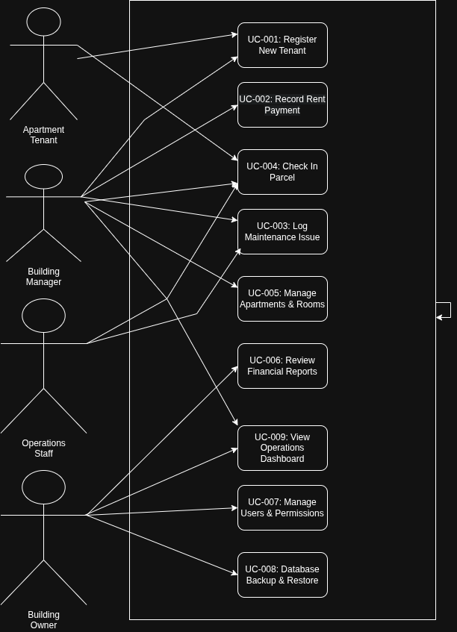
Figure B.1 — AMS Use Case Diagram

B.2 Detailed Use Case Descriptions

UC-001: Register New Tenant
Field | Description
Use Case ID | UC-001
Name | Register New Tenant
Goal | Create a complete tenant record and assign the tenant to an available apartment.
Primary Actor | Building Manager
Preconditions | The manager is authenticated; the apartment exists, is active, and has available capacity.
Postconditions | Tenant and assignment are saved; occupancy status is recalculated; an audit event is recorded.
Trigger | Manager selects New Tenant.
Main Flow | 1. Manager opens the tenant registration form. 2. Manager enters tenant identity and contact details. 3. Manager selects an active apartment and confirms move-in date. 4. System validates required fields, uniqueness, capacity, and assignment rules. 5. System saves the tenant and assignment in one transaction. 6. System updates the apartment occupancy status and shows confirmation.
Alternative Flows | A1. If the apartment is partially occupied but has capacity, the system permits assignment and marks it Partially Occupied.
Exceptions | E1. Missing or invalid required data prevents saving and identifies the fields. E2. The selected apartment has no available capacity; the system rejects the assignment.
Related Requirements | FR-001–FR-005, BR-001–BR-003

UC-002: Record Rent Payment
Field | Description
Use Case ID | UC-002
Name | Record Rent Payment
Goal | Record and classify a tenant rent payment and update the outstanding balance.
Primary Actor | Building Manager
Preconditions | The manager is authenticated; tenant and apartment records exist; the rent period is selected.
Postconditions | Payment record is saved; status and balance are recalculated; receipt reference is available.
Trigger | Manager selects Record Payment.
Main Flow | 1. Manager selects tenant and rent period. 2. System displays configured rent and current balance. 3. Manager enters amount, payment method, date, and receipt reference. 4. System validates amount and payment method. 5. System saves the payment and recalculates balance. 6. System displays Full, Partial, Pending, or Overdue status and confirmation.
Alternative Flows | A1. A partial amount is saved with Partial status and the remaining balance.
Exceptions | E1. Amount is zero, negative, or invalid; the system rejects the entry. E2. An unapproved duplicate receipt reference is entered; the system requests correction.
Related Requirements | FR-007–FR-012, BR-004–BR-007

UC-003: Log Maintenance Issue
Field | Description
Use Case ID | UC-003
Name | Log Maintenance Issue
Goal | Register, prioritize, and route a repair request through its resolution workflow.
Primary Actor | Building Manager
Preconditions | The manager is authenticated; the apartment exists.
Postconditions | Issue is saved as Open; priority and description are visible; assignment/status history can be updated.
Trigger | Manager selects New Issue.
Main Flow | 1. Manager selects the apartment and enters issue description and category. 2. Manager selects Low, Medium, High, or Critical priority. 3. System validates the description and priority. 4. System saves the issue with Open status and timestamp. 5. Manager optionally assigns responsible staff and changes status to In Progress. 6. Authorized user records resolution notes and changes status to Resolved.
Alternative Flows | A1. A Critical issue is highlighted for immediate attention. A2. A resolved issue may be reopened only with an explanation.
Exceptions | E1. Empty description prevents saving. E2. A non-authorized user cannot change assignment or status.
Related Requirements | FR-013–FR-016, BR-008–BR-009

UC-004: Check In Parcel
Field | Description
Use Case ID | UC-004
Name | Check In Parcel
Goal | Record a courier parcel and later confirm tenant pickup.
Primary Actor | Building Manager
Preconditions | The manager is authenticated; tenant record exists.
Postconditions | Parcel is saved as Received with storage location; later pickup confirmation changes status to Picked Up.
Trigger | Courier delivers a parcel to the building.
Main Flow | 1. Manager opens parcel check-in. 2. Manager selects tenant and enters courier, tracking number, received date, and storage location. 3. System validates tenant and parcel details. 4. System saves the parcel with Received status. 5. When tenant collects it, manager opens the parcel record. 6. Manager records pickup date and receiver confirmation. 7. System changes status to Picked Up and shows confirmation.
Alternative Flows | A1. If no tracking number is supplied, the parcel may be saved with a blank tracking number.
Exceptions | E1. Unknown tenant prevents check-in. E2. Pickup cannot be confirmed without date and receiver confirmation.
Related Requirements | FR-017–FR-019, BR-010–BR-011

B.3 Activity Diagram — Register New Tenant (UC-001)
End-to-end process flow for tenant registration, including validation, capacity checking, and rejection/acceptance branches.
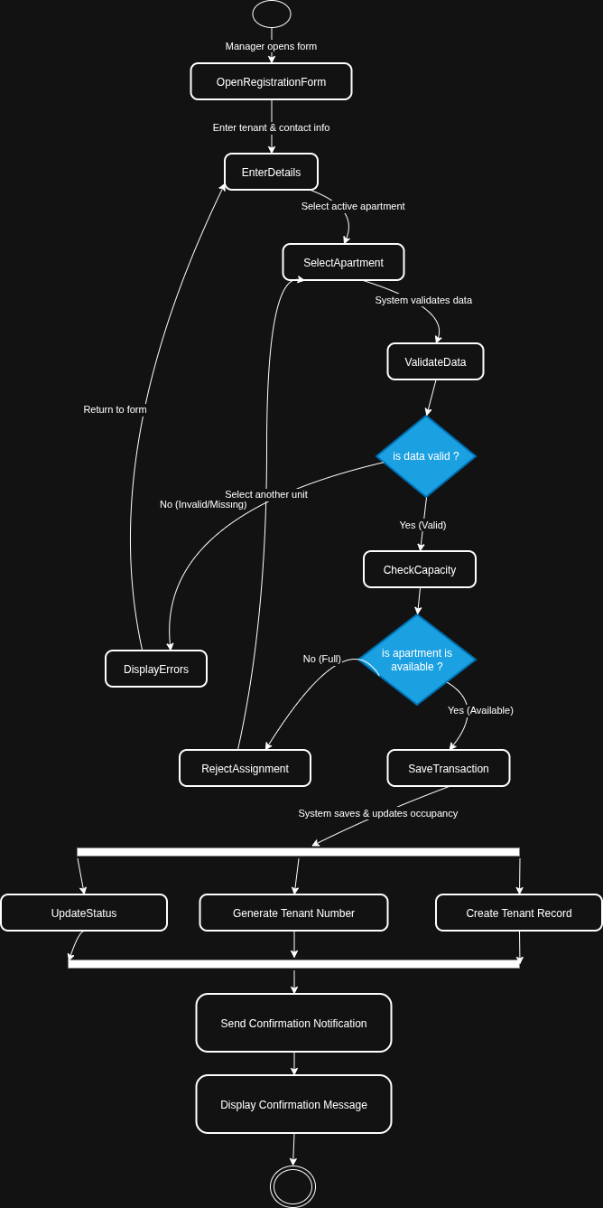
Figure B.2 — Activity Diagram for UC-001: Register New Tenant

B.4 Swimlane Diagram — Maintenance Issue Workflow
Cross-role workflow for logging and resolving a maintenance issue, showing handoffs between the Building Manager, the AMS System, and Operations Staff.
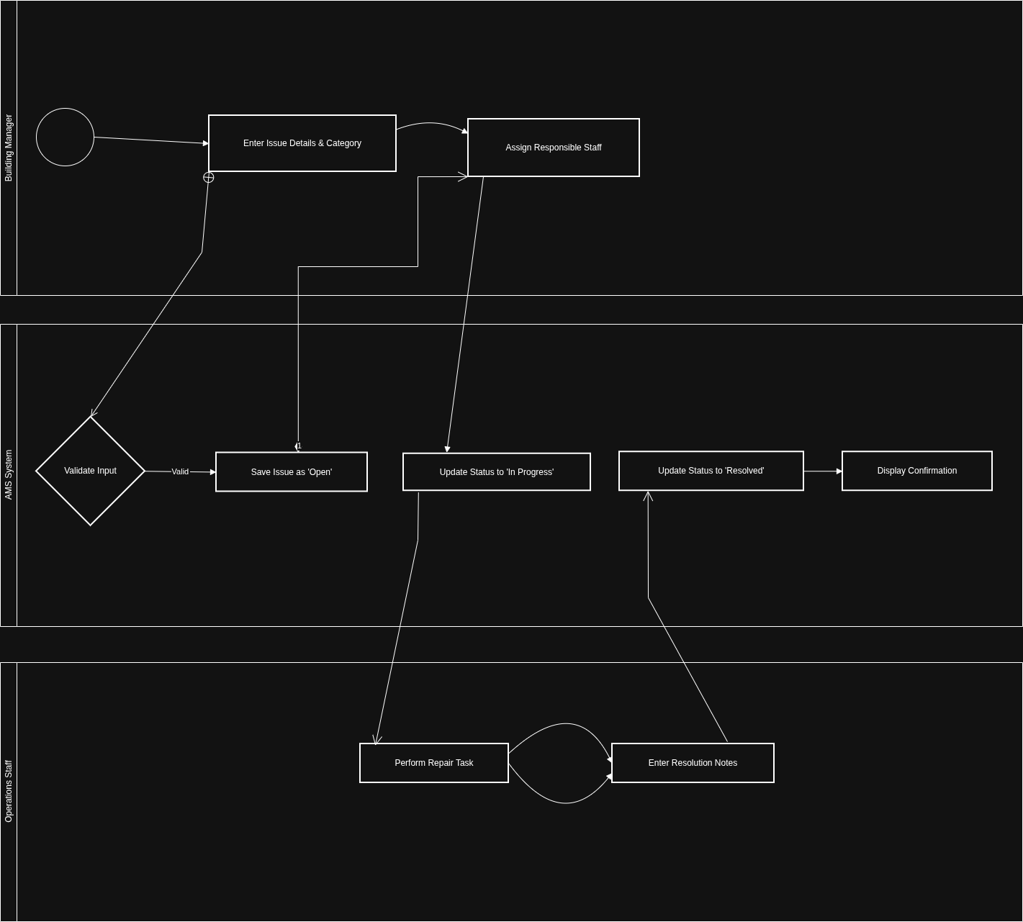
Figure B.3 — Swimlane Diagram: Maintenance Issue Workflow

B.5 Sequence Diagram — Record Rent Payment (UC-002)
Interaction sequence between the Building Manager, the Payment Form (UI), the Rent Service (Logic), and the Database, including the valid/invalid amount alternative.
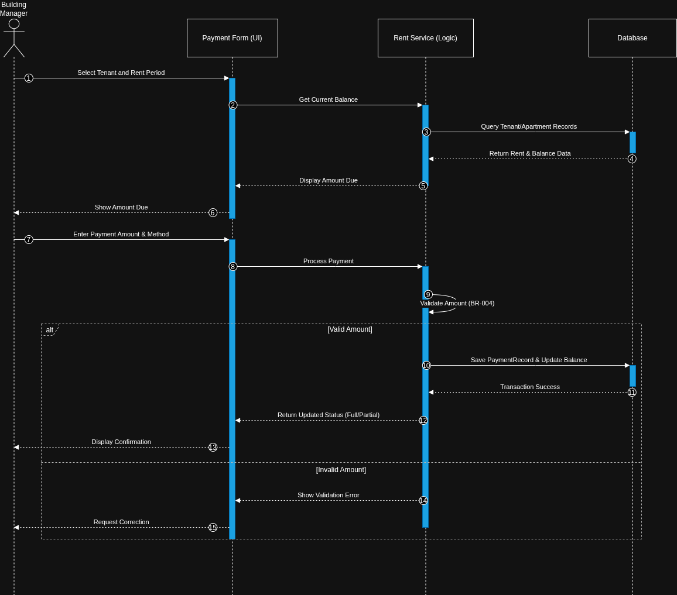
Figure B.4 — Sequence Diagram: Record Rent Payment

B.6 State Diagram — Maintenance Issue Lifecycle
Lifecycle states of a maintenance Issue object: Open, Assigned, In Progress, Resolved, and Cancelled, with governing transitions.
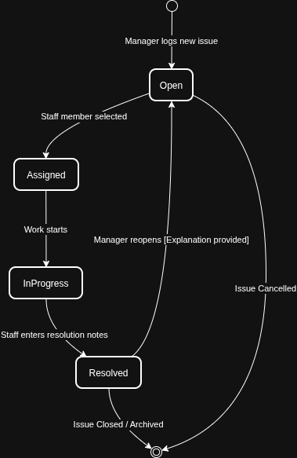
Figure B.5 — State Diagram: Issue Lifecycle

Appendix C: Issues List
This register captures unresolved requirements, pending decisions, unclear rules, and assumptions requiring stakeholder confirmation. Owners should resolve high-impact items before baselining the SRS.
ID | Description | Status | Priority | Owner | Impact
ISS-001 | Confirm whether one tenant may have multiple historical assignments and how long inactive assignments must be retained. | Open | High | Mohammed Alsamawi | Affects tenant history and data model.
ISS-002 | Confirm the official rent due date policy for each period. | Open | High | Eng. Rasheed Aldhaferi | Affects overdue classification and reports.
ISS-003 | Confirm whether a docket payment requires a docket number and a standard format. | Open | Medium | Building Owners | Affects payment validation and auditability.
ISS-004 | Confirm the approved list of maintenance categories and the definition of Critical priority. | Open | Medium | Aiham Alhalmi | Affects issue classification and escalation.
ISS-005 | Confirm whether parcel storage locations require a controlled list or free text. | Open | Low | Building Managers | Affects parcel form design.
ISS-006 | Confirm backup destination policy, retention count, and whether backup files may be stored on removable media. | Open | High | Building Owners | Affects recovery and security procedures.
ISS-007 | Confirm password reset process for a fully offline deployment. | Open | High | Building Owners | Affects account recovery and support.
ISS-008 | Confirm the Arabic translation owner and review process for CR-003. | Open | Medium | Eng. Rasheed Aldhaferi | Affects localization quality and release readiness.
ISS-009 | Confirm whether tenants will have direct system access in V1.0 or remain secondary beneficiaries. | In Progress | High | Mohammed Alsamawi | Affects user classes, permissions, and UI scope.
ISS-010 | Confirm whether PDF reports require a fixed institutional template or only readable local export. | Open | Low | Eng. Rasheed Aldhaferi | Affects CR-002 report layout.
ISS-011 | Confirm whether the system should keep an immutable audit history for corrected payments. | Open | Medium | Building Owners | Affects audit data and maintainability.
ISS-012 | Confirm supported minimum screen resolution and accessibility expectations for the Windows desktop. | Open | Medium | Habib Sabri | Affects interface layout and usability testing.

Review Guidance
Open issues should be reviewed during the next stakeholder session. When a decision is made, the owner should update the issue status to Resolved, record the decision in the requirements baseline, and update any affected FR, NFR, BR, IR, DR, UC, US, or AC identifiers.

